ROAD ACCIDENT REPORT SQL QUERIES
CY Casualties
SELECT SUM(number_of_casualties) as CY_Casualties
from road_accident
where year(accident_date)='2022'
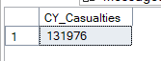

CY Accidents
SELECT count(distinct accident_index) as CY_Accidents
from road_accident
where year(accident_date)='2022'
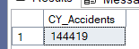

CY Fatal Casualties
SELECT sum(number_of_casualties) as CY_Fatal_Casualties
from road_accident
where year(accident_date)='2022' and accident_severity = 'Fatal'
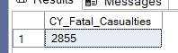

CY Serious Casualties(the same for Slight)
SELECT sum(number_of_casualties) as CY_Serious_Casualties
from road_accident
where year(accident_date)='2022' and accident_severity = 'Serious'

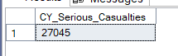

PCT Slight casualties( same for fatal and serious)
select cast(sum(number_of_casualties) as decimal(10,2)) *100 /
(select cast(sum(number_of_casualties) as Decimal(10,2)) from road_accident) as PCT
from road_accident
where year(accident_date)='2022' and accident_severity = 'Slight'
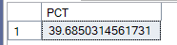

Casualties by Vehicle Type

Select
case
when vehicle_type in ('Agricultural vehicle') then 'Aricultural'
when vehicle_type in ('Motorcyle 125cc and under','Motorcycle 50cc and under','Motorcycle over 125cc and up to 500cc','Motorcycle over 500cc','Pedal cycle') then 'bike'
when vehicle_type in ('Bus or coach (17 or more pass seats)','Minibus(8 - 16 passenger seats)') then 'Bus'
when vehicle_type in ('Goods 7.5 tonnes mgw and over','Goods over 3.5t. and under 7.5t','Van / Goods 3.5 tonnes mgw or under') then 'Van'
Else 'Other'
end as vehicle_group,
Sum(number_of_casualties) as CY_Casualties
From road_accident
where year(accident_date)='2022'
group by
case
when vehicle_type in ('Agricultural vehicle') then 'Aricultural'
when vehicle_type in ('Motorcyle 125cc and under','Motorcycle 50cc and under','Motorcycle over 125cc and up to 500cc','Motorcycle over 500cc','Pedal cycle') then 'bike'
when vehicle_type in ('Bus or coach (17 or more pass seats)','Minibus(8 - 16 passenger seats)') then 'Bus'
when vehicle_type in ('Goods 7.5 tonnes mgw and over','Goods over 3.5t. and under 7.5t','Van / Goods 3.5 tonnes mgw or under') then 'Van'
Else 'Other'
End

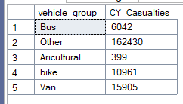

CY casualties Monthly
select datename(month,accident_date) as Month_Name,
sum(number_of_casualties)
from road_accident
where year(accident_date)='2022'
group by datename(month,accident_date)
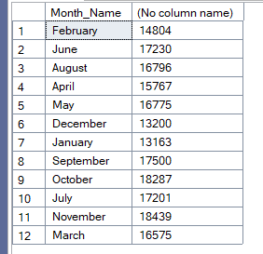

CY Casualties by Road Type
select road_type, sum(number_of_casualties) as CY_Casualties
from road_accident
where year(accident_date)='2022'
group by road_type
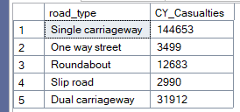

PCT Casualties by Area
select urban_or_rural_area, sum(number_of_casualties) as CY_casualties,cast(sum(number_of_casualties)as decimal(10,2)) * 100 /
(select cast(sum(number_of_casualties)as decimal(10,2)) from road_accident
where year(accident_date)='2022') as PCT_casualties
from road_accident
where year(accident_date)='2022'
group by urban_or_rural_area
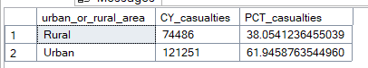

Casualties by Light Condition
select
case
when light_conditions in('Daylight') then 'Day'
when light_conditions in('Darkness - lighting unknown','Darkness - lights lit','Darkness - lights unlit','Darkness - no lighting') then 'Night'
end as Light_Condition,
cast(cast(sum(number_of_casualties) as decimal(10,2)) *100 /
(select cast(sum(number_of_casualties) as decimal(10,2)) from road_accident
where year(accident_date)='2022') as decimal(10,2))
as CY_Casualties_PCT
from road_accident
where year(accident_date)='2022'
Group by
case
when light_conditions in('Daylight') then 'Day'
when light_conditions in('Darkness - lighting unknown','Darkness - lights lit','Darkness - lights unlit','Darkness - no lighting') then 'Night'
end
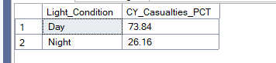
Top 10 Locations by Total Casualties
select top 10 local_authority, sum(number_of_casualties) as Total_Casualties
from road_accident
group by local_authority
order by Total_Casualties Desc
